Practice Test 1 - Results

 Return to review

Attempt 1

All knowledge areas

All questions

Top of Form

Question 1: **Correct**

**Yes, this service can be used to receive messages from multiple devices. The data can then be relayed to an Azure Storage account.**

**You have to construct a program that would make use of the Azure Batch service. The program would make use of the Azure Batch service to covert files and store the output in an Azure Storage account.**

**Snippets of the program are given below**

**You have to ensure that the code segments are completed correctly.**

[Larger image](javascript:void(0))

[[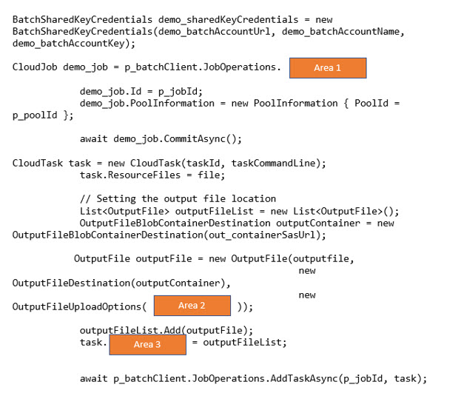](javascript:void(0))](javascript:void(0))

**Which of the following would go into Area 1?**

* ​

GetJob

* ​

GetTask

* ​

EnableJob

* ​

CreateJob

**(Correct)**

**Explanation**

Here the code snippet is trying to create a new job. This method comes as part of batch client job operations.

Bottom of Form

Top of Form

Question 2: **Incorrect**

**The next set of 2 questions are based on the following scenario**

**You have to construct a program that would make use of the Azure Batch service. The program would make use of the Azure Batch service to covert files and store the output in an Azure Storage account.**

**Snippets of the program are given below**

**You have to ensure that the code segments are completed correctly.**

[Larger image](javascript:void(0))

[[](javascript:void(0))](javascript:void(0))

**Which of the following would go into Area 2?**

* ​

OutputFileUploadCondition.TaskSuccess

**(Correct)**

* ​

StorageContainerURL.TaskSuccess

**(Incorrect)**

* ​

StorageContainer.TaskSuccess

* ​

HttpUrl.TaskSuccess

**Explanation**

Here we have to mention the option of OutputFileUploadCondition.TaskSuccess

Bottom of Form

Top of Form

Question 3: **Correct**

**You have to construct a program that would make use of the Azure Batch service. The program would make use of the Azure Batch service to covert files and store the output in an Azure Storage account.**

**Snippets of the program are given below**

**You have to ensure that the code segments are completed correctly.**

[Larger image](javascript:void(0))

[[](javascript:void(0))](javascript:void(0))

**Which of the following would go into Area 3?**

* ​

ResourceFiles

* ​

StorageFiles

* ​

OutputFiles

**(Correct)**

* ​

InputFiles

**Explanation**

Since we are mentioning output files, these need to be part of the task

Bottom of Form

Top of Form

Question 4: Skipped

**You have to develop a program in ASP.Net. This program will be required to search for keywords in a data store. The program needs to ensure it creates the required indexes in the Azure Search account. Which of the following objects do you need to implement as part of the solution? Choose 2 answers from the options given below**

* ​

SearchService

* ​

SearchIndexClient

* ​

SearchServiceClient

**(Correct)**

* ​

SearchCredentials

**(Correct)**

**Explanation**

The SearchCredentials object will be used to store the credentials of the Azure Search account. The SearchServiceClient object will be used to connect to the Search Service Account.

Bottom of Form

Top of Form

Question 5: **Correct**

**The next set of 4 questions are based on the following scenario**

**Your team has developed the following Azure Function. The function is used to take messages from a queue and add them to queue storage.**

**#r "Microsoft.WindowsAzure.Storage"**

**#r "Newtonsoft.Json"**

**using Microsoft.WindowsAzure.Storage.Queue;**

**using Newtonsoft.Json;**

**using System;**

**public static void Run(CloudQueueMessage myItem,ICollector<Customer> outputTable,ILogger log)**

**{**

**log.Info(myItem.Id);**

**log.Info(myItem.InsertionTime);**

**log.Info(myItem.ExpirationTime);**

**outputTable.Add(**

**JsonConvert.DeserializeObject<Customer>(myItem.AsString));**

**}**

**public class Customer**

**{**

**public string PartitionKey { get; set; }**

**public string RowKey { get; set; }**

**}**

**Would the code log the time the message was processed from the queue?**

* ​

Yes

**(Correct)**

* ​

No

**Explanation**

Since the Insertion Time is being logged, yes, this is true.

Bottom of Form

Top of Form

Question 6: **Correct**

**Your team has developed the following Azure Function. The function is used to take messages from a queue and add them to queue storage.**

**#r "Microsoft.WindowsAzure.Storage"**

**#r "Newtonsoft.Json"**

**using Microsoft.WindowsAzure.Storage.Queue;**

**using Newtonsoft.Json;**

**using System;**

**public static void Run(CloudQueueMessage myItem,ICollector<Customer> outputTable,ILogger log)**

**{**

**log.Info(myItem.Id);**

**log.Info(myItem.InsertionTime);**

**log.Info(myItem.ExpirationTime);**

**outputTable.Add(**

**JsonConvert.DeserializeObject<Customer>(myItem.AsString));**

**}**

**public class Customer**

**{**

**public string PartitionKey { get; set; }**

**public string RowKey { get; set; }**

**}**

**Would the code add Customer records to the table?**

* ​

Yes

**(Correct)**

* ​

No

**Explanation**

Yes, since you have a table binding and a valid statement to add the message from the queue, this will work as intended.

Bottom of Form

Top of Form

Question 7: **Incorrect**

**Your team has developed the following Azure Function. The function is used to take messages from a queue and add them to queue storage.**

**#r "Microsoft.WindowsAzure.Storage"**

**#r "Newtonsoft.Json"**

**using Microsoft.WindowsAzure.Storage.Queue;**

**using Newtonsoft.Json;**

**using System;**

**public static void Run(CloudQueueMessage myItem,ICollector<Customer> outputTable,ILogger log)**

**{**

**log.Info(myItem.Id);**

**log.Info(myItem.InsertionTime);**

**log.Info(myItem.ExpirationTime);**

**outputTable.Add(**

**JsonConvert.DeserializeObject<Customer>(myItem.AsString));**

**}**

**public class Customer**

**{**

**public string PartitionKey { get; set; }**

**public string RowKey { get; set; }**

**}**

**If there are multiple customers being added to the queue, would all the customer entities be added to the table via multiple executions of the function?**

* ​

Yes

**(Correct)**

* ​

No

**(Incorrect)**

**Explanation**

Yes, the function would be triggered for every message in the queue.

Bottom of Form

Top of Form

Question 8: **Incorrect**

**Your team has developed the following Azure Function. The function is used to take messages from a queue and add them to queue storage.**

**#r "Microsoft.WindowsAzure.Storage"**

**#r "Newtonsoft.Json"**

**using Microsoft.WindowsAzure.Storage.Queue;**

**using Newtonsoft.Json;**

**using System;**

**public static void Run(CloudQueueMessage myItem,ICollector<Customer> outputTable,ILogger log)**

**{**

**log.Info(myItem.Id);**

**log.Info(myItem.InsertionTime);**

**log.Info(myItem.ExpirationTime);**

**outputTable.Add(**

**JsonConvert.DeserializeObject<Customer>(myItem.AsString));**

**}**

**public class Customer**

**{**

**public string PartitionKey { get; set; }**

**public string RowKey { get; set; }**

**}**

**If the ‘Run’ fails, would the function retry up to five times to process the queue message?**

* ​

Yes

**(Correct)**

* ​

No

**(Incorrect)**

**Explanation**

Yes, by default, the triggers such as BLOB, queue triggers will be retried upto 5 times. After the fifth retry, the triggers sends a message to a special poison queue.

Bottom of Form

Top of Form

Question 9: **Incorrect**

**The next set of 6 questions are based on the following scenario**

**You need to deploy a new Windows virtual machine to your Azure subscription. You need to configure Azure Disk Encryption for the virtual machine. You need to create a script based on Azure CLI commands to implement the requirement.**

**Below are the Azure CLI commands that would be used for the implementation. You have to**

**complete the missing parts of the commands.**

[Larger image](javascript:void(0))

[[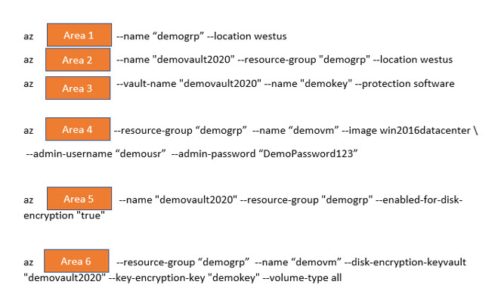](javascript:void(0))](javascript:void(0))

**Which of the following will come in the Slot Area 1?**

* ​

keyvault create

* ​

keyvault key create

* ​

group create

**(Correct)**

* ​

vm create

**(Incorrect)**

**Explanation**

First, we have to run the command to create a new resource group.

Bottom of Form

Top of Form

Question 10: **Correct**

**You need to deploy a new Windows virtual machine to your Azure subscription. You need to configure Azure Disk Encryption for the virtual machine. You need to create a script based on Azure CLI commands to implement the requirement.**

**Below are the Azure CLI commands that would be used for the implementation. You have to complete the missing parts of the commands.**

[Larger image](javascript:void(0))

[[](javascript:void(0))](javascript:void(0))

**Which of the following will come in the Slot Area 2?**

* ​

keyvault create

**(Correct)**

* ​

keyvault key create

* ​

group create

* ​

vm create

**Explanation**

Next, we have to run the command to create a new key vault.

Bottom of Form

Top of Form

Question 11: **Correct**

**You need to deploy a new Windows virtual machine to your Azure subscription. You need to configure Azure Disk Encryption for the virtual machine. You need to create a script based on Azure CLI commands to implement the requirement.**

**Below are the Azure CLI commands that would be used for the implementation. You have to complete the missing parts of the commands.**

[Larger image](javascript:void(0))

[[](javascript:void(0))](javascript:void(0))

**Which of the following will come in the Slot Area 3?**

* ​

keyvault create

* ​

keyvault key create

**(Correct)**

* ​

group create

* ​

vm create

**Explanation**

Next, we have to run the command to create a new key in the key vault

Bottom of Form

Top of Form

Question 12: **Incorrect**

**You need to deploy a new Windows virtual machine to your Azure subscription. You need to configure Azure Disk Encryption for the virtual machine. You need to create a script based on Azure CLI commands to implement the requirement.**

**Below are the Azure CLI commands that would be used for the implementation. You have to complete the missing parts of the commands.**

[Larger image](javascript:void(0))

[[](javascript:void(0))](javascript:void(0))

**Which of the following will come in the Slot Area 4?**

* ​

keyvault create

* ​

keyvault key create

* ​

group create

**(Incorrect)**

* ​

vm create

**(Correct)**

**Explanation**

Next, we have to run the command to create a new virtual machine

Bottom of Form

Top of Form

Question 13: **Incorrect**

**You need to deploy a new Windows virtual machine to your Azure subscription. You need to configure Azure Disk Encryption for the virtual machine. You need to create a script based on Azure CLI commands to implement the requirement.**

**Below are the Azure CLI commands that would be used for the implementation. You have to complete the missing parts of the commands.**

[Larger image](javascript:void(0))

[[](javascript:void(0))](javascript:void(0))

**Which of the following will come in the Slot Area 5?**

* ​

keyvault create

* ​

keyvault key create

* ​

keyvault update

**(Correct)**

* ​

vm encryption enable

**(Incorrect)**

**Explanation**

Next, we have to run the command to ensure the policy of the key vault allows for Azure Disk Encryption

Bottom of Form

Top of Form

Question 14: **Incorrect**

**You need to deploy a new Windows virtual machine to your Azure subscription. You need to configure Azure Disk Encryption for the virtual machine. You need to create a script based on Azure CLI commands to implement the requirement.**

**Below are the Azure CLI commands that would be used for the implementation. You have to complete the missing parts of the commands.**

[Larger image](javascript:void(0))

[[](javascript:void(0))](javascript:void(0))

**Which of the following will come in the Slot Area 6?**

* ​

keyvault create

* ​

keyvault key create

**(Incorrect)**

* ​

keyvault update

* ​

vm encryption enable

**(Correct)**

**Explanation**

Next, we have to run the command to encrypt the virtual machine

Bottom of Form

Top of Form

Question 15: **Incorrect**

**The next set of 2 questions are based on the following scenario**

**A team currently has a storage account defined in Azure. For the storage account, they have created a shared access signature with the following details**

[Larger image](javascript:void(0))

[[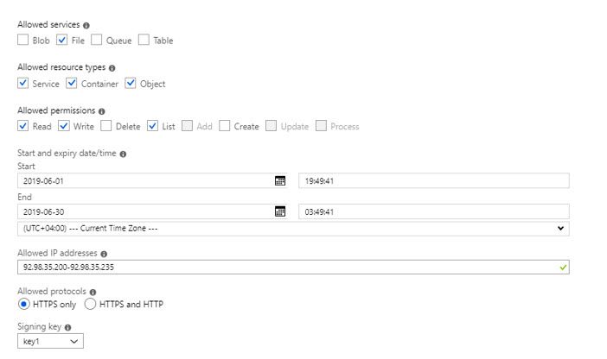](javascript:void(0))](javascript:void(0))

**If one tries to access the storage account on 10th of June 2019 using Azure Storage Explorer from a computer with an IP address of 95.98.35.100, what would be the end result?**

* ​

You will not be granted access

**(Correct)**

* ​

You will be prompted for credentials

**(Incorrect)**

* ​

You will have only read access to the file shares

* ​

You will have read, write and list access for the file shares

**Explanation**

Since the IP address is not in the allowed range, you will get an authorization error.

Bottom of Form

Top of Form

Question 16: **Incorrect**

**A team currently has a storage account defined in Azure. For the storage account, they have created a shared access signature with the following details**

[Larger image](javascript:void(0))

[[](javascript:void(0))](javascript:void(0))

**If one tries to access the storage account on 10th of June 2019 using Azure Storage Explorer from a computer with an IP address of 92.98.35.232, what would be the end result?**

* ​

You will not be granted access

* ​

You will be prompted for credentials

**(Incorrect)**

* ​

You will have only read access to the file shares

* ​

You will have read, write and list access for the file shares

**(Correct)**

**Explanation**

Since the IP address is in the valid range, you will be able to access the storage account. And since the allowed permissions are Read, Write and List, this will be allowed via the SAS URI

Bottom of Form

Top of Form

Question 17: **Correct**

**The next set of 3 questions are based on the following scenario**

**Your team is planning on deploying a web application to the Azure web App service. The application itself interacts with a Service Bus queue.**

**The scaling for the web application is based on the number of active messages processed in the Service Bus queue.**

**Currently there is a rule in place to scale up the application whenever the number of active messages processed is less than 200.**

**You need to add a rule which would scale down the App service whenever the scale up condition is not met**

**You need to configure the scale in rule**

**Which of the following would you configure as the metric source?**

[Larger image](javascript:void(0))

[[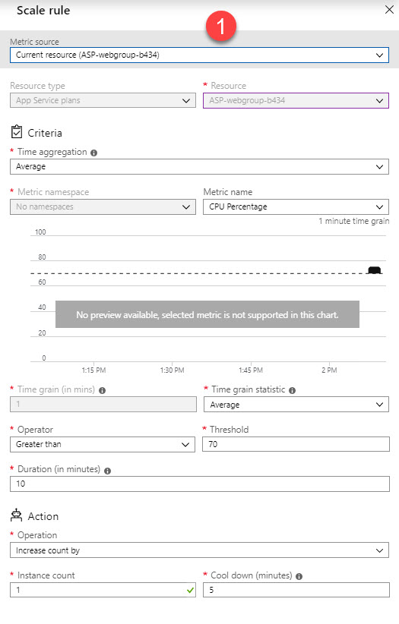](javascript:void(0))](javascript:void(0))

* ​

Current resource

* ​

Storage Queue

* ​

Service Bus Queue

**(Correct)**

**Explanation**

Since the scale out rule is based on the number of messages in the service bus queue, we also have to also base the scale in rule on the number of messages in the queue itself. For this we need to select the metric source as the Service Bus queue.

Bottom of Form

Top of Form

Question 18: **Incorrect**

**Your team is planning on deploying a web application to the Azure web App service. The application itself interacts with a Service Bus queue.**

**The scaling for the web application is based on the number of active messages processed in the Service Bus queue.**

**Currently there is a rule in place to scale up the application whenever the number of active messages processed is less than 200.**

**You need to add a rule which would scale down the App service whenever the scale up condition is not met**

**You need to configure the scale in rule**

**Which of the following would you choose as the operator?**

[Larger image](javascript:void(0))

[[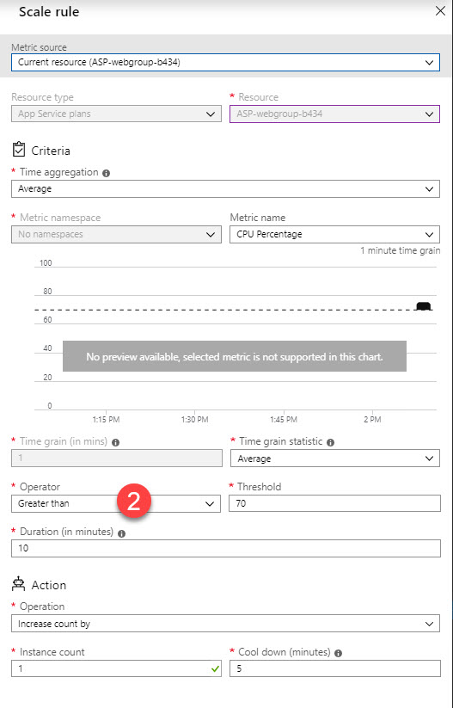](javascript:void(0))](javascript:void(0))

* ​

Greater than

* ​

Greater than or equal to

**(Correct)**

* ​

Less than

**(Incorrect)**

* ​

Less than or equal to

**Explanation**

Since in the scale out rule, we check whether the number of active messages is less than 200, for the scale in rule, we can check if the number of messages is greater than or equal to 200.

Bottom of Form

Top of Form

Question 19: **Correct**

**Your team is planning on deploying a web application to the Azure web App service. The application itself interacts with a Service Bus queue.**

**The scaling for the web application is based on the number of active messages processed in the Service Bus queue.**

**Currently there is a rule in place to scale up the application whenever the number of active messages processed is less than 200.**

**You need to add a rule which would scale down the App service whenever the scale up condition is not met**

**You need to configure the scale in rule**

**Which of the following should be choose as the “Action operation”?**

[Larger image](javascript:void(0))

[[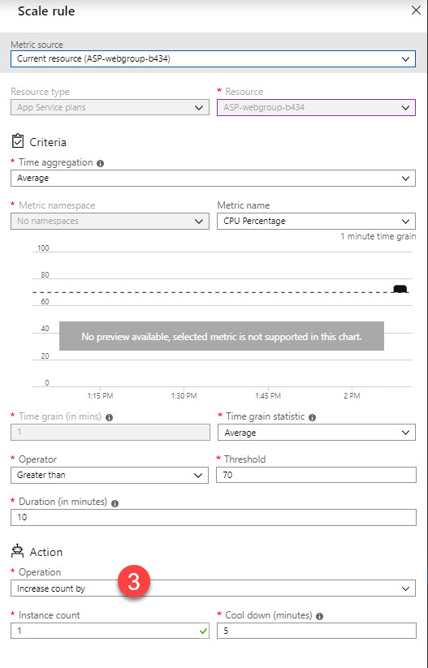](javascript:void(0))](javascript:void(0))

* ​

Increase count by

* ​

Increase count to

* ​

Decrease count by

**(Correct)**

* ​

Decrease count to

**Explanation**

In the scale out rule, it means that we increase the number of instances as part of the web app. In a scale in rule, we have to perform an operation to decrease the number of instances. Since the question does not mention the number of instances to decrease the count to, we can perform an incremental decrease in the number of instances.

Bottom of Form

Top of Form

Question 20: **Incorrect**

**You have a storage account defined in Azure. You have created a table called “Customers” using the Table service. The data in the table is partitioned via the Last name. You need to create a query in C# that returns all the customer data with the last name of “Cole”. Which of the following code segment should you use?**

* ​

TableQuery.GenerateFilterCondition(“PartitionKey”, Equals,”Cole”);

* ​

TableQuery.GenerateFilterCondition(“LastName”, Equals,”Cole”);

* ​

TableQuery.GenerateFilterCondition(“PartitionKey”,QueryComparisons.Equal,”Cole”);

**(Correct)**

* ​

TableQuery.GenerateFilterCondition(“LastName”, QueryComparisons.Equal,”Cole”);

**(Incorrect)**

**Explanation**

The Filter condition needs to query via the Partition Key since the Last name is the Partition Key.

Bottom of Form

Top of Form

Question 21: **Correct**

**The next set of 3 questions are based on the following scenario**

**A company is developing an application for a hospital. The application is going to store patient data in a Cosmos DB account. The default consistency level of the database is set to String. You have to override the consistency level at the query level to ensure the query requirement is being met. You need to ensure the latency and the impact to the application is minimized.**

**Which of the following consistency level would you use for the following requirement?**

**“Ensure the query returns the most recent patient status”**

* ​

Strong

**(Correct)**

* ​

Bounded Staleness

* ​

Consistent Prefix

* ​

Eventual

**Explanation**

Here we have to choose Strong as the consistency level. This ensures that the recent committed version of an item is always returned.

Bottom of Form

Top of Form

Question 22: **Incorrect**

**A company is developing an application for a hospital. The application is going to store patient data in a Cosmos DB account. The default consistency level of the database is set to String. You have to override the consistency level at the query level to ensure the query requirement is being met. You need to ensure the latency and the impact to the application is minimized.**

**Which of the following consistency level would you use for the following requirement?**

**“Ensure that the health data of the patient retuned in no less than one version behind”**

* ​

Strong

* ​

Bounded Staleness

**(Correct)**

* ​

Consistent Prefix

* ​

Eventual

**(Incorrect)**

**Explanation**

With Bounded stateless, you can mention by how many versions the reads can lag behind the writes.

Bottom of Form

Top of Form

Question 23: **Incorrect**

**A company is developing an application for a hospital. The application is going to store patient data in a Cosmos DB account. The default consistency level of the database is set to String. You have to override the consistency level at the query level to ensure the query requirement is being met. You need to ensure the latency and the impact to the application is minimized.**

**Which of the following consistency level would you use for the following requirement?**

**“Ensure that when the patient is finally discharged, all charges are assessed, and the final charge is presented to the patient”**

* ​

Strong

* ​

Bounded Staleness

**(Incorrect)**

* ​

Consistent Prefix

* ​

Eventual

**(Correct)**

**Explanation**

Here we can have the best latency. Here we can wait for all charges to be assessed and then finally take the final charge since there would be no more writes to the charges.

Bottom of Form

Top of Form

Question 24: **Correct**

**The next set of 4 questions are based on the following scenario**

**You have to develop an application that will work with Azure Table storage. The table will store the following fields – CustomerName , CustomerPhone and CustomerEmail.**

**a) The CustomerName field will be used to load balance the data in the table**

**b) The CustomerPhone may contain null values for some of the customers.**

**You have to complete the following code for interacting with the Customer Table in Azure Storage.**

[Larger image](javascript:void(0))

[[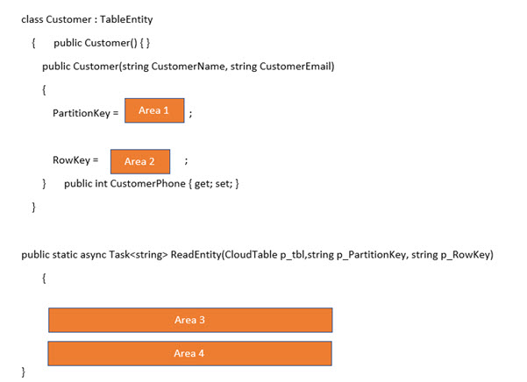](javascript:void(0))](javascript:void(0))

**Which of the following would go into Area 1?**

* ​

CustomerName

**(Correct)**

* ​

CustomerEmail

**Explanation**

Since the CustomerName is going to be used to load balance the data, it needs to be set as the Partition Key.

Bottom of Form

Top of Form

Question 25: **Correct**

**You have to develop an application that will work with Azure Table storage. The table will store the following fields – CustomerName , CustomerPhone and CustomerEmail.**

**a) The CustomerName field will be used to load balance the data in the table**

**b) The CustomerPhone may contain null values for some of the customers.**

**You have to complete the following code for interacting with the Customer Table in Azure Storage.**

[Larger image](javascript:void(0))

[[](javascript:void(0))](javascript:void(0))

**Which of the following would go into Area 2?**

* ​

CustomerName

* ​

CustomerEmail

**(Correct)**

**Explanation**

The CustomerEmail can be set as the Row Key

Bottom of Form

Top of Form

Question 26: **Correct**

**You have to develop an application that will work with Azure Table storage. The table will store the following fields – CustomerName , CustomerPhone and CustomerEmail.**

**a) The CustomerName field will be used to load balance the data in the table**

**b) The CustomerPhone may contain null values for some of the customers.**

**You have to complete the following code for interacting with the Customer Table in Azure Storage.**

[Larger image](javascript:void(0))

[[](javascript:void(0))](javascript:void(0))

**Which of the following would go into Area 3?**

* ​

TableEntity readop = TableEntity.Retrieve<Customer>(p_PartitionKey, p_RowKey);

* ​

TableOperation readop = TableOperation.Retrieve<Customer>(p_PartitionKey, p_RowKey);

**(Correct)**

* ​

TableResult readop = TableResult.Retrieve<Customer>(p_PartitionKey, p_RowKey);

* ​

TableResultSet readop = TableResultSet.Retrieve<Customer>(p_PartitionKey, p_RowKey);

**Explanation**

Here we need to use the Table operation class.

Bottom of Form

Top of Form

Question 27: Skipped

**You have to develop an application that will work with Azure Table storage. The table will store the following fields – CustomerName , CustomerPhone and CustomerEmail.**

**a) The CustomerName field will be used to load balance the data in the table**

**b) The CustomerPhone may contain null values for some of the customers.**

**You have to complete the following code for interacting with the Customer Table in Azure Storage.**

[Larger image](javascript:void(0))

[[](javascript:void(0))](javascript:void(0))

**Which of the following would go into Area 4?**

* ​

TableResult data = await p_tbl.ExecuteAsync(readop);

**(Correct)**

* ​

TableEntity data = await p_tbl.ExecuteAsync(readop);

* ​

TableQuery data = await p_tbl.ExecuteAsync(readop);

* ​

TableOperation data = await p_tbl.ExecuteAsync(readop);

**Explanation**

Here we need to use the TableResult data type

Bottom of Form

Top of Form

Question 28: **Incorrect**

**You have to deploy an Azure Kubernetes cluster. The cluster will be used to host various container-based applications. You have to create the cluster and ensure the applications are deployed properly. Which of the following steps would you implement for this requirement? Choose 4 answers from the options given below**

* ​

az aks get-credentials

**(Correct)**

* ​

az appservice plan create

**(Incorrect)**

* ​

az aks create

**(Correct)**

* ​

az group create

**(Correct)**

* ​

kubectl apply

**(Correct)**

**Explanation**

The first step is to create the resource group via the command - az group create

The next step is to create the Kubernetes cluster via the command - az aks create

Next we need to get the credentials for the cluster to deploy the applications - az aks get-credentials

And finally, we use the kubectl apply command to apply the deployment files.

Bottom of Form

Top of Form

Question 29: **Correct**

**You have a web application deployed to Azure via the Azure Web Service. The Azure Web Service uses the D1 App service plan. The user load on the application is now having an impact on the page load times of the application. You need to ensure that the web application automatically scales when the CPU percentage goes beyond 80 percent and also ensure costs are minimized. Which of the following actions would you perform for this requirement? Choose 4 answers from the options given below**

* ​

Enable autoscaling on the web application

**(Correct)**

* ​

Configure a scale rule

**(Correct)**

* ​

Configure the web app service plan to the Standard tier

**(Correct)**

* ​

Configure the web app service plan to the Premium tier

* ​

Configure a scale condition

**(Correct)**

**Explanation**

First ensure to scale up the App Service Plan to Standard. This supports Autoscaling and is also cost effective

Next, enable autoscaling for the web application

Next, configure a scale condition and a scale rule.

Bottom of Form

Top of Form

Question 30: **Incorrect**

**Your company has an Azure Web App service. You have to grant a developer a contributor role to the Azure Web app. This needs to be done so that the developer can publish code to the web application. Which of the following two commands would you issue for this requirement? Each of the commands is a complete solution.**

* ​

New-AzureRmRoleAssignment

**(Correct)**

* ​

az role assignment create

**(Correct)**

* ​

az role definition create

**(Incorrect)**

* ​

New-AzureRmRoleDefinition

**(Incorrect)**

**Explanation**

Here you can perform a role assignment either via Powershell or via the Azure command line interface

Bottom of Form

Top of Form

Question 31: **Incorrect**

**You have to create a Docker image that runs an ASP.Net core application. The application is named “demoapp”. You run the container-based application, there is a setup script that needs to run named “setup.ps1” and the main application file “demoapp.dll”. You need to create a Docker file that would meet the following requirements**

**a) Call the setup script when the container is built**

**b) Run the application file “demoapp.dll” when the container starts**

**c) The Dockerfile document will be in the same folder as the application file and the setup script**

**Which of the following four commands would you add to the Dockerfile?**

* ​

RUN powershell ./setup.ps1

CMD [“dotnet”,” demoapp.dll”]

**(Incorrect)**

* ​

EXPOSE ./demoapp/ /apps/demoapp

* ​

COPY ./.

**(Correct)**

* ​

FROM microsoft/aspnetcore:2.2

**(Correct)**

* ​

WORKDIR /apps/demoapp

**(Correct)**

* ​

CMD powershell ./setup.ps1

ENTRYPOINT [“dotnet”,” demoapp.dll”]

**(Correct)**

**Explanation**

You first need to specify the base image to build the application - FROM microosft/aspnetcore:2.2

Next set the working directory - WORKDIR /apps/demoapp

Next copy the files - COPY ./.

And then ensure to use the ENTRYPOINT to specify the DLL which will run when the container starts

Bottom of Form

Top of Form

Question 32: **Correct**

**You have gone ahead and developed a web application. You plan to host the website in Azure. You expect the website to experience high traffic volumes after it is published. You must ensure that the website remains available and responsive while minimizing cost. You need to deploy the website. Which of the following would you implement for this scenario?**

* ​

Deploy the website to an App Service that uses the Shared service tier. Configure the App Service plan to automatically scale when the CPU load is high.

* ​

Deploy the website to a virtual machine. Configure the virtual machine to automatically scale when the CPU load is high.

* ​

Deploy the website to an App Service that uses the Standard service tier. Configure the App Service plan to automatically scale when the CPU load is high.

**(Correct)**

**Explanation**

Ensure the Web application is deployed to an Azure Web App. The App Service plan needs to be standard or higher. Then enable Autoscaling for the web application. For scaling on virtual machines , ensure to deploy a virtual machine scale set.

Bottom of Form

Top of Form

Question 33: **Incorrect**

**The following set of 2 questions are based on the following scenario**

**You are developing an application that is going to interact with an Azure Redis Cache database.**

**You have to ensure that when a product data information is changed, the data in the cache is invalidated**

**You need to complete the following code snippet for this**

[Larger image](javascript:void(0))

[[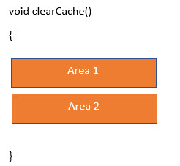](javascript:void(0))](javascript:void(0))

**Which of the following would go into Area 1?**

* ​

IDatabase cache = Connection.GetDatabase();

**(Correct)**

* ​

ICache cache = Connection.GetDatabase();

**(Incorrect)**

**Explanation**

The database needs to of the interface type IDatabase

Bottom of Form

Top of Form

Question 34: **Incorrect**

**You are developing an application that is going to interact with an Azure Redis Cache database.**

**You have to ensure that when a product data information is changed, the data in the cache is invalidated**

**You need to complete the following code snippet for this**

[Larger image](javascript:void(0))

[[](javascript:void(0))](javascript:void(0))

**Which of the following would go into Area 2?**

* ​

Cache.StringGet(“productdata”);

* ​

Cache.StringSet(“productdata”,””);

**(Correct)**

* ​

Cache.ValueDelete(“productdata”);

**(Incorrect)**

* ​

Cache.KeyDelete(“productdata”);

**Explanation**

Here you can just reset the value of the Key to invalidate the data.

Bottom of Form

Top of Form

Question 35: **Correct**

**The following set of 5 questions is based on the following scenario**

**A company has an Azure Search Account. You need to create an Index with the following fields**

**a) ID**

**b) Name**

**c) Location**

**d) Phone**

**e) Description**

**f) Rating**

**g) List of Cuisines**

**You should be able to develop a search criterion for the Index based on the following requirements**

**a) Users must be able to search for restaurants based on the name, description, location, phone, rating and cuisine**

**b) Users must be able to narrow results further by location, cuisine and rating**

**You need to complete the below missing annotation from the class to meet the requirements**

[Larger image](javascript:void(0))

[[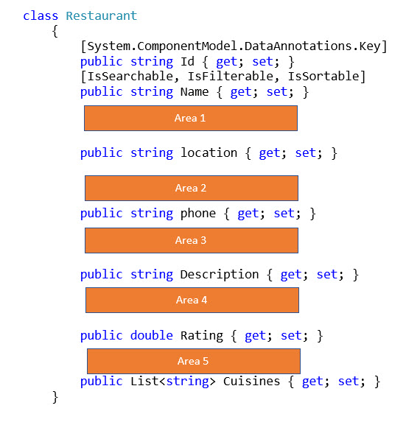](javascript:void(0))](javascript:void(0))

**Which of the following would go into Area 1?**

* ​

[IsSearchable, IsFilterable, IsSortable, IsFacetable]

**(Correct)**

* ​

[IsSearchable]

* ​

[IsSearchable,Required]

* ​

[IsFilterable, Required]

**Explanation**

Since the location field needs to at least be searchable and filterable, we need to choose this as the best option. To have the ability to narrow results down, means we need to ensure the field is filterable.

Bottom of Form

Top of Form

Question 36: **Incorrect**

**A company has an Azure Search Account. You need to create an Index with the following fields**

**a) ID**

**b) Name**

**c) Location**

**d) Phone**

**e) Description**

**f) Rating**

**g) List of Cuisines**

**You should be able to develop a search criterion for the Index based on the following requirements**

**a) Users must be able to search for restaurants based on the name, description, location, phone, rating and cuisine**

**b) Users must be able to narrow results further by location, cuisine and rating**

**You need to complete the below missing annotation from the class to meet the requirements**

[Larger image](javascript:void(0))

[[](javascript:void(0))](javascript:void(0))

**Which of the following would go into Area 2?**

* ​

[Required]

* ​

[IsFilterable, IsFacetable, Required]

* ​

[IsSearchable]

**(Correct)**

* ​

[IsFilterable, IsFacetable, IsSortable]

**(Incorrect)**

**Explanation**

Since the phone field just needs to be searchable, we can just have that as the attribute.

Bottom of Form

Top of Form

Question 37: **Incorrect**

**A company has an Azure Search Account. You need to create an Index with the following fields**

**a) ID**

**b) Name**

**c) Location**

**d) Phone**

**e) Description**

**f) Rating**

**g) List of Cuisines**

**You should be able to develop a search criterion for the Index based on the following requirements**

**a) Users must be able to search for restaurants based on the name, description, location, phone, rating and cuisine**

**b) Users must be able to narrow results further by location, cuisine and rating**

**You need to complete the below missing annotation from the class to meet the requirements**

[Larger image](javascript:void(0))

[[](javascript:void(0))](javascript:void(0))

**Which of the following would go into Area 3?**

* ​

[Required]

* ​

[IsSearchable]

**(Correct)**

* ​

[IsFilterable, IsFacetable, Required]

* ​

[IsFilterable, IsFacetable, IsSortable]

**(Incorrect)**

**Explanation**

Since the description field just needs to be searchable, we can just have that as the attribute.

Bottom of Form

Top of Form

Question 38: **Incorrect**

**A company has an Azure Search Account. You need to create an Index with the following fields**

**a) ID**

**b) Name**

**c) Location**

**d) Phone**

**e) Description**

**f) Rating**

**g) List of Cuisines**

**You should be able to develop a search criterion for the Index based on the following requirements**

**a) Users must be able to search for restaurants based on the name, description, location, phone, rating and cuisine**

**b) Users must be able to narrow results further by location, cuisine and rating**

**You need to complete the below missing annotation from the class to meet the requirements**

[Larger image](javascript:void(0))

[[](javascript:void(0))](javascript:void(0))

**Which of the following would go into Area 4?**

* ​

[IsFilterable, IsSortable, IsFacetable]

* ​

[IsFilterable, IsSortable, Required]

**(Incorrect)**

* ​

[IsFilterable, IsSortable, IsSearchable]

**(Correct)**

* ​

[IsFilterable, IsSortable, Key, Required]

**Explanation**

Since the rating field needs to at least be searchable and filterable, we need to choose this as the best option. To have the ability to narrow results down, means we need to ensure the field is filterable.

Bottom of Form

Top of Form

Question 39: Skipped

**A company has an Azure Search Account. You need to create an Index with the following fields**

**a) ID**

**b) Name**

**c) Location**

**d) Phone**

**e) Description**

**f) Rating**

**g) List of Cuisines**

**You should be able to develop a search criterion for the Index based on the following requirements**

**a) Users must be able to search for restaurants based on the name, description, location, phone, rating and cuisine**

**b) Users must be able to narrow results further by location, cuisine and rating**

**You need to complete the below missing annotation from the class to meet the requirements**

[Larger image](javascript:void(0))

[[](javascript:void(0))](javascript:void(0))

**Which of the following would go into Area 5?**

* ​

[IsFilterable, IsSortable, IsSearchable]

**(Correct)**

* ​

[IsFilterable, IsSortable, IsFacetable]

* ​

[IsFilterable, IsSortable, Required]

* ​

[IsFilterable, IsSortable, Key, Required]

**Explanation**

Since the Cuisines field needs to at least be searchable and filterable, we need to choose this as the best option. To have the ability to narrow results down, means we need to ensure the field is filterable.

Bottom of Form

Top of Form

Question 40: Skipped

**The next set of 3 questions is based on the following scenario**

**You are developing an ASP.Net application to deliver on-demand video. The video is delivered via an Azure Content Delivery Network. You have created an endpoint for this.**

**An example URL used by users to download the video is given below**

**https://cloudportalhub.com/video.mp4?quality=h**

**You need to comply with the following requirements**

**a) Ensure all media content expires from the cache after an hour**

**b) Videos of varying quality must be delivered from the closest regional point of presence**

**You need to set the caching rules**

**Which of the following would you set as the caching behaviour?**

* ​

Bypass cache

* ​

Override

**(Correct)**

* ​

Set if missing

**Explanation**

Here since we have to ensure the videos expire from the cache after an hour, we need to explicitly set the caching behavior by overriding any cache settings set from the origin.

Bottom of Form

Top of Form

Question 41: **Correct**

**You are developing an ASP.Net application to deliver on-demand video. The video is delivered via an Azure Content Delivery Network. You have created an endpoint for this.**

**An example URL used by users to download the video is given below**

**https://cloudportalhub.com/video.mp4?quality=h**

**You need to comply with the following requirements**

**a) Ensure all media content expires from the cache after an hour**

**b) Videos of varying quality must be delivered from the closest regional point of presence**

**You need to set the caching rules**

**Which of the following would you set as the cache expiration duration?**

* ​

1 second

* ​

1 minute

* ​

1 hour

**(Correct)**

* ​

1 day

**Explanation**

Since the question clearly mentions that we need to cache the videos for 1 hour, we need to set this as the cache expiration duration.

Bottom of Form

Top of Form

Question 42: **Incorrect**

**You are developing an ASP.Net application to deliver on-demand video. The video is delivered via an Azure Content Delivery Network. You have created an endpoint for this.**

**An example URL used by users to download the video is given below**

**https://cloudportalhub.com/video.mp4?quality=h**

**You need to comply with the following requirements**

**a) Ensure all media content expires from the cache after an hour**

**b) Videos of varying quality must be delivered from the closest regional point of presence**

**You need to set the caching rules**

**Which of the following would you set as the Query string caching behavior?**

* ​

Ignore query strings

* ​

Bypass caching for query strings

**(Incorrect)**

* ​

Cache every unique URL

**(Correct)**

**Explanation**

Since each video of each quality (which is specified by the URL) needs to be cached, we need to ensure every unique URL is cached.

Bottom of Form

Top of Form

Question 43: **Incorrect**

**The following set of 3 questions are based on the following scenario**

**A company wants to setup a Kubernetes cluster. They want a team to be able to develop and deploy the application in isolation. They want to ensure the team can work without the need to replicate or mockup dependencies or other applications in the same cluster. You need to set up the cluster for this purpose using an Azure CLI command.**

[Larger image](javascript:void(0))

[[](javascript:void(0))](javascript:void(0))

**Which of the following would go into Area 1?**

* ​

group

**(Incorrect)**

* ​

acr

* ​

aks

**(Correct)**

**Explanation**

Here we need to update the Kubernetes cluster to use Dev spaces, hence we need to issue the “az aks” command

Bottom of Form

Top of Form

Question 44: **Incorrect**

**A company wants to setup a Kubernetes cluster. They want a team to be able to develop and deploy the application in isolation. They want to ensure the team can work without the need to replicate or mockup dependencies or other applications in the same cluster. You need to set up the cluster for this purpose using an Azure CLI command.**

[Larger image](javascript:void(0))

[[](javascript:void(0))](javascript:void(0))

**Which of the following would go into Area 2?**

* ​

aks

**(Incorrect)**

* ​

use-dev-spaces

**(Correct)**

* ​

isolate-app

**Explanation**

Here we need to use “dev spaces” to isolate the application

Bottom of Form

Top of Form

Question 45: **Incorrect**

**A company wants to setup a Kubernetes cluster. They want a team to be able to develop and deploy the application in isolation. They want to ensure the team can work without the need to replicate or mockup dependencies or other applications in the same cluster. You need to set up the cluster for this purpose using an Azure CLI command.**

[Larger image](javascript:void(0))

[[](javascript:void(0))](javascript:void(0))

**Which of the following would go into Area 3?**

* ​

--space

**(Correct)**

* ​

--slot

**(Incorrect)**

* ​

--type

**Explanation**

Here we need to mention a space name

Bottom of Form

Top of Form

Question 46: **Incorrect**

**Your company has an existing MongoDB database in their on-premise infrastructure. They need to migrate the database to Cosmos DB. Which of the following tool can be used to migrate the database content?**

* ​

The azcopy tool

* ​

The Azure Database Migration Service

**(Correct)**

* ​

The Cosmos DB migration tool

**(Incorrect)**

**Explanation**

You can use the Azure Database Migration Service to migrate the data onto Cosmos DB. For more information one can visit the URL -<https://docs.microsoft.com/en-us/azure/dms/tutorial-mongodb-cosmos-db>

Bottom of Form

Top of Form

Question 47: Skipped

**Your company has an Azure Virtual Network defined In Azure. They have created an Azure Logic App named “demoworkflow”. The logic apps and integration accounts need secure access to the virtual machines defined in the Virtual network. Which of the following could be used to secure the required access?**

* ​

Virtual Network Service Endpoint

* ​

Integration Service Environments

**(Correct)**

* ​

Isolated Networks

**Explanation**

You can use Integration Service Environments to service this purpose. For more information one can visit the URL - <https://docs.microsoft.com/en-us/azure/logic-apps/connect-virtual-network-vnet-isolated-environment-overview>

Bottom of Form

Top of Form

Question 48: **Incorrect**

**The below set of 3 questions are based on the following scenario**

**You’ve developed and deployed a Web API to the Azure Web Service. You have attached a custom domain to the Azure Web App with the name of https://cloudportalhub.com. Another web application is trying to consume the API via the URL https://cloudhubdemo.com**

**The Web Applications gets the following error**

**“Response to preflight request doesn't pass access control check: No 'Access-Control-Allow-Origin' header is present on the requested resource.”**

**You need to complete the below Azure CLI commands that could be used to resolve this issue.**

[Larger image](javascript:void(0))

[[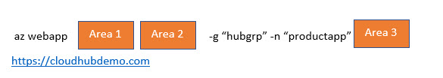](javascript:void(0))](javascript:void(0))

**Which of the following would go into Area 1?**

* ​

config

**(Incorrect)**

* ​

cors

**(Correct)**

* ​

connection

**Explanation**

The error is coming because we are not allowing Cross Origin Resource sharing. To have the setting in place for the Azure Web App, we need to issue the “az webapp cors” command.

Bottom of Form

Top of Form

Question 49: **Incorrect**

**You’ve developed and deployed a Web API to the Azure Web Service. You have attached a custom domain to the Azure Web App with the name of https://cloudportalhub.com. Another web application is trying to consume the API via the URL https://cloudhubdemo.com**

**The Web Applications gets the following error**

**“Response to preflight request doesn't pass access control check: No 'Access-Control-Allow-Origin' header is present on the requested resource.”**

**You need to complete the below Azure CLI commands that could be used to resolve this issue.**

[Larger image](javascript:void(0))

[[](javascript:void(0))](javascript:void(0))

**Which of the following would go into Area 2?**

* ​

add

**(Correct)**

* ​

list

* ​

update

**(Incorrect)**

**Explanation**

Here we need to add the source URL of the application that is trying to consume the Web API

Bottom of Form

Top of Form

Question 50: **Incorrect**

**You’ve developed and deployed a Web API to the Azure Web Service. You have attached a custom domain to the Azure Web App with the name of https://cloudportalhub.com. Another web application is trying to consume the API via the URL https://cloudhubdemo.com**

**The Web Applications gets the following error**

**“Response to preflight request doesn't pass access control check: No 'Access-Control-Allow-Origin' header is present on the requested resource.”**

**You need to complete the below Azure CLI commands that could be used to resolve this issue.**

[Larger image](javascript:void(0))

[[](javascript:void(0))](javascript:void(0))

**Which of the following would go into Area 3?**

* ​

--URL

**(Incorrect)**

* ​

--connection

* ​

--allowed-origins

**(Correct)**

**Explanation**

Here we have to set the –allowed-origins flag - <https://docs.microsoft.com/en-us/cli/azure/webapp/cors?view=azure-cli-latest>

Bottom of Form

Top of Form

Question 51: **Incorrect**

**The following set of 5 questions are based on the following scenario**

**You have to create an Azure CLI script that needs to publish code from GitHub onto an Azure Web App. The script needs to create the resource group, the app service plan and the web app as well.**

**Below are the variables used in the script**

**$repo=https://github.com/alashro/WebAppNew**

**$appname=”newapp1020”**

[Larger image](javascript:void(0))

[[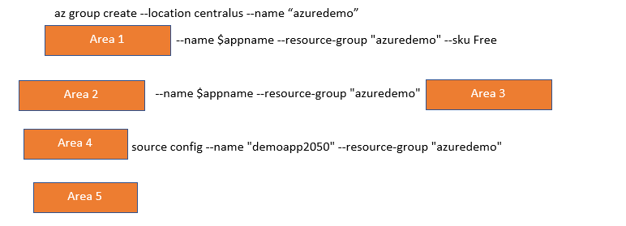](javascript:void(0))](javascript:void(0))

**Which of the following would go into Area 1?**

* ​

az webapp create

**(Incorrect)**

* ​

az appservice plan create

**(Correct)**

* ​

az webapp deployment

* ​

az webapp set

**Explanation**

The first step is to create an App service plan

Bottom of Form

Top of Form

Question 52: **Incorrect**

**You have to create an Azure CLI script that needs to publish code from GitHub onto an Azure Web App. The script needs to create the resource group, the app service plan and the web app as well.**

**Below are the variables used in the script**

**$repo=https://github.com/alashro/WebAppNew**

**$appname=”newapp1020”**

[Larger image](javascript:void(0))

[[](javascript:void(0))](javascript:void(0))

**Which of the following would go into Area 2?**

* ​

az webapp create

**(Correct)**

* ​

az appservice plan create

**(Incorrect)**

* ​

az webapp deployment

* ​

az webapp set

**Explanation**

The next step is to create the web app itself.

Bottom of Form

Top of Form

Question 53: **Correct**

**You have to create an Azure CLI script that needs to publish code from GitHub onto an Azure Web App. The script needs to create the resource group, the app service plan and the web app as well.**

**Below are the variables used in the script**

**$repo=https://github.com/alashro/WebAppNew**

**$appname=”newapp1020”**

[Larger image](javascript:void(0))

[[](javascript:void(0))](javascript:void(0))

**Which of the following would go into Area 3?**

* ​

--repo-url $repo –branch master –manual-integration

* ​

git clone $repo

* ​

--plan $appname

**(Correct)**

**Explanation**

Here we need to specify the plan name for the Azure Web App

Bottom of Form

Top of Form

Question 54: **Incorrect**

**You have to create an Azure CLI script that needs to publish code from GitHub onto an Azure Web App. The script needs to create the resource group, the app service plan and the web app as well.**

**Below are the variables used in the script**

**$repo=https://github.com/alashro/WebAppNew**

**$appname=”newapp1020”**

[Larger image](javascript:void(0))

[[](javascript:void(0))](javascript:void(0))

**Which of the following would go into Area 4?**

* ​

az webapp create

* ​

az appservice plan create

* ​

az webapp deployment

**(Correct)**

* ​

az webapp set

**(Incorrect)**

**Explanation**

Here we have to deploy the application from GitHub

Bottom of Form

Top of Form

Question 55: **Correct**

**You have to create an Azure CLI script that needs to publish code from GitHub onto an Azure Web App. The script needs to create the resource group, the app service plan and the web app as well.**

**Below are the variables used in the script**

**$repo=https://github.com/alashro/WebAppNew**

**$appname=”newapp1020”**

[Larger image](javascript:void(0))

[[](javascript:void(0))](javascript:void(0))

**Which of the following would go into Area 5?**

* ​

--repo-url $repo –branch master –manual-integration

**(Correct)**

* ​

git clone $repo

* ​

--plan $appname

**Explanation**

Here we have to specify the repository URL

Bottom of Form

Top of Form

Question 56: **Correct**

**The next set of 4 questions are based on the following scenario**

**You have to develop an application for a company. The application would store information for an online training system. The application would be working with data from a Student and Course table. The application would be connecting to an Azure database and be using the Entity Framework.**

**Below is a snippet of application code. The code is supposed to add a new student and add a record between the new student and an existing course.**

**namespace app**

**{**

**public class StudentDbContext : DbContext**

**{**

**public StudentDbContext() :base (“name=databaseconnstring”){}**

**public DbSet<Student> Students {get; set;}**

**public DbSet<Course> Courses {get; set;}**

**protected override void OnModelCreating(DbModelBuilder modeBuilder)**

**{**

**modeBuilder.Entity<Student>().HasMany(x=>x.Courses).WithMany(x=>x.Students);**

**}**

**}**

**public class courseapp**

**{**

**public void CreateStudent(int studentid, int courseid)=>AddStudent(studentid,GetCourse(courseid));**

**public Course GetCourse(int courseid)**

**{**

**using (var db=new StudentDbContext())**

**{**

**return db.Courses.FirstOrDefault(x=>x.Courseid==courseid));**

**}**

**}**

**public Student AddSudent(int studentid, string name,Course course)**

**{**

**using (var db=new StudentDbContext())**

**{**

**var student= new Student() { studentid= studentid , studentname =name, Courses=new List<Course>(){course}};**

**db.Students.Add(student);**

**db.SaveChanges();**

**return student;**

**}**

**}**

**}**

**public class Course**

**{**

**public int Courseid { get; set; }**

**public string CourseName { get; set; }**

**public virtual List<Student> Students { get; set; }**

**}**

**public class Student**

**{**

**public int studentid { get; set; }**

**public string studentname { get; set; }**

**public virtual List<Course> Courses { get; set; }**

**}**

**}**

**Would the code successfully insert a new student record?**

* ​

Yes

**(Correct)**

* ​

No

**Explanation**

The code is correctly adding a student record with a reference to a course record.

Bottom of Form

Top of Form

Question 57: **Incorrect**

**You have to develop an application for a company. The application would store information for an online training system. The application would be working with data from a Student and Course table. The application would be connecting to an Azure database and be using the Entity Framework.**

**Below is a snippet of application code. The code is supposed to add a new student and add a record between the new student and an existing course.**

**namespace app**

**{**

**public class StudentDbContext : DbContext**

**{**

**public StudentDbContext() :base (“name=databaseconnstring”){}**

**public DbSet<Student> Students {get; set;}**

**public DbSet<Course> Courses {get; set;}**

**protected override void OnModelCreating(DbModelBuilder modeBuilder)**

**{**

**modeBuilder.Entity<Student>().HasMany(x=>x.Courses).WithMany(x=>x.Students);**

**}**

**}**

**public class courseapp**

**{**

**public void CreateStudent(int studentid, int courseid)=>AddStudent(studentid,GetCourse(courseid));**

**public Course GetCourse(int courseid)**

**{**

**using (var db=new StudentDbContext())**

**{**

**return db.Courses.FirstOrDefault(x=>x.Courseid==courseid));**

**}**

**}**

**public Student AddSudent(int studentid, string name,Course course)**

**{**

**using (var db=new StudentDbContext())**

**{**

**var student= new Student() { studentid= studentid , studentname =name, Courses=new List<Course>(){course}};**

**db.Students.Add(student);**

**db.SaveChanges();**

**return student;**

**}**

**}**

**}**

**public class Course**

**{**

**public int Courseid { get; set; }**

**public string CourseName { get; set; }**

**public virtual List<Student> Students { get; set; }**

**}**

**public class Student**

**{**

**public int studentid { get; set; }**

**public string studentname { get; set; }**

**public virtual List<Course> Courses { get; set; }**

**}**

**}**

**Does the code have a bug, and would it insert an additional copy of a Course record with a new courseid?**

* ​

Yes

**(Incorrect)**

* ​

No

**(Correct)**

**Explanation**

The code makes a reference to get an existing course based on a course id. It also creates a new list and adds a reference to an existing course.

Bottom of Form

Top of Form

Question 58: **Incorrect**

**You have to develop an application for a company. The application would store information for an online training system. The application would be working with data from a Student and Course table. The application would be connecting to an Azure database and be using the Entity Framework.**

**Below is a snippet of application code. The code is supposed to add a new student and add a record between the new student and an existing course.**

**namespace app**

**{**

**public class StudentDbContext : DbContext**

**{**

**public StudentDbContext() :base (“name=databaseconnstring”){}**

**public DbSet<Student> Students {get; set;}**

**public DbSet<Course> Courses {get; set;}**

**protected override void OnModelCreating(DbModelBuilder modeBuilder)**

**{**

**modeBuilder.Entity<Student>().HasMany(x=>x.Courses).WithMany(x=>x.Students);**

**}**

**}**

**public class courseapp**

**{**

**public void CreateStudent(int studentid, int courseid)=>AddStudent(studentid,GetCourse(courseid));**

**public Course GetCourse(int courseid)**

**{**

**using (var db=new StudentDbContext())**

**{**

**return db.Courses.FirstOrDefault(x=>x.Courseid==courseid));**

**}**

**}**

**public Student AddSudent(int studentid, string name,Course course)**

**{**

**using (var db=new StudentDbContext())**

**{**

**var student= new Student() { studentid= studentid , studentname =name, Courses=new List<Course>(){course}};**

**db.Students.Add(student);**

**db.SaveChanges();**

**return student;**

**}**

**}**

**}**

**public class Course**

**{**

**public int Courseid { get; set; }**

**public string CourseName { get; set; }**

**public virtual List<Student> Students { get; set; }**

**}**

**public class Student**

**{**

**public int studentid { get; set; }**

**public string studentname { get; set; }**

**public virtual List<Course> Courses { get; set; }**

**}**

**}**

**Does the code have a bug, and would it insert a wrong Courseid value?**

* ​

Yes

**(Incorrect)**

* ​

No

**(Correct)**

**Explanation**

The code makes a reference to get an existing course based on a course id. It also creates a new list and adds a reference to an existing course.

Bottom of Form

Top of Form

Question 59: **Correct**

**You have to develop an application for a company. The application would store information for an online training system. The application would be working with data from a Student and Course table. The application would be connecting to an Azure database and be using the Entity Framework.**

**Below is a snippet of application code. The code is supposed to add a new student and add a record between the new student and an existing course.**

**namespace app**

**{**

**public class StudentDbContext : DbContext**

**{**

**public StudentDbContext() :base (“name=databaseconnstring”){}**

**public DbSet<Student> Students {get; set;}**

**public DbSet<Course> Courses {get; set;}**

**protected override void OnModelCreating(DbModelBuilder modeBuilder)**

**{**

**modeBuilder.Entity<Student>().HasMany(x=>x.Courses).WithMany(x=>x.Students);**

**}**

**}**

**public class courseapp**

**{**

**public void CreateStudent(int studentid, int courseid)=>AddStudent(studentid,GetCourse(courseid));**

**public Course GetCourse(int courseid)**

**{**

**using (var db=new StudentDbContext())**

**{**

**return db.Courses.FirstOrDefault(x=>x.Courseid==courseid));**

**}**

**}**

**public Student AddSudent(int studentid, string name,Course course)**

**{**

**using (var db=new StudentDbContext())**

**{**

**var student= new Student() { studentid= studentid , studentname =name, Courses=new List<Course>(){course}};**

**db.Students.Add(student);**

**db.SaveChanges();**

**return student;**

**}**

**}**

**}**

**public class Course**

**{**

**public int Courseid { get; set; }**

**public string CourseName { get; set; }**

**public virtual List<Student> Students { get; set; }**

**}**

**public class Student**

**{**

**public int studentid { get; set; }**

**public string studentname { get; set; }**

**public virtual List<Course> Courses { get; set; }**

**}**

**}**

**There is a valid many-to-many relationship between the Students and Courses data?**

* ​

Yes

**(Correct)**

* ​

No

**Explanation**

The modelBuilder line “modeBuilder.Entity<Student>().HasMany(x=>x.Courses).WithMany(x=>x.Students);” mentions the right statements for adding a many-to-many relationship.

Bottom of Form

Top of Form

Question 60: **Correct**

**You need to implement Application Insights for a web-based application. You need to capture data that would be used to analyse user behaviour. Which of the following data values would you capture as part of Application Insights? Choose 3 answers from the options given below**

* ​

Trace

* ​

Session Id

**(Correct)**

* ​

Exception

* ​

User Id

**(Correct)**

* ​

Events

**(Correct)**

**Explanation**

Capture the User Id and Session Id to keep track of the users and sessions. Also keep track of custom events from within your application.

Bottom of Form

Continue

Retake test